EXTRACTION OF KEYWORDS AND SUMMARIZATION OF CHAIRMAN SPEECH ON ANNUAL REPORTS

Ayan Roy-C23008
Krishna Pradhan-C23016
Prem Sambhaji Jadhav-C23021
Soumyojit Basu-C23032
Tarun Yadav-C23037
Advisor: Prof. Subhashish Dasgupta

October 31, 2023

Acknowledgement
We are immensely grateful for the invaluable guidance and unwavering support provided by our esteemed supervisor, Professor Subhashish Dasgupta, who holds the position of Professor at Praxis Business School, Kolkata. His expert advice, constant encouragement, and insightful suggestions have illuminated our path throughout the entire project. His remarkable patience, visionary outlook and unwavering support were particularly valuable during challenging moments in our research journey. Under his esteemed supervision, we had the privilege of gaining invaluable experience, honing our time management skills, and fostering independent thinking. Working alongside him has been both an exciting and enriching experience.

Abstract
This report presents a comprehensive study on the extraction of keywords and the subsequent summarization of Chairman's speeches from annual reports. The aim of this research is to automate the process of distilling essential information and insights from these critical sections of annual reports. To achieve this, various natural language processing techniques were employed, including keyword extraction. The methodology involved the collection of a diverse set of annual reports from various industries and organizations. Through the web application keywords were identified, allowing us to uncover the most frequently occurring terms and themes within Chairman's speeches, the automated extraction of keywords and the summarization of Chairman's speeches in annual reports offer a valuable tool for investors, analysts, and stakeholders seeking to quickly grasp the key messages and sentiments expressed by corporate leadership. This research contributes to enhancing the efficiency of information retrieval and decision-making processes in the domain of corporate finance and governance.

Contents
List of Figures………………………………………………………………………………….4
1 Introduction…………………………………………………………………………………..5
1.1 Annual Reports……………………………………………………………………...5
1.2 Role of Chairman’s Speech………………………………………………………..6
2 Methodology…………………………………………………………………………………8
2.1 Profiled Companies………………………………………………………………...8
2.2 Data Collection……………………………………………………………………...8
2.3 Keyword Marking……………………………………………………………………9
2.4 Preprocessing……………………………………………………………………….9
2.5 Modeling……………………………………………………………………………11
2.5.1 NER Model………………………………………………………………………11
2.5.2 RoBERTa Model………………………………………………………………11
2.5.3 NER Model Hyperparameters…………………………………………………12
2.5.4 BART Summarization Model…………………………………………………..14
3 Model Deployment…………………………………………………………………………16
4 Investment Opportunities………………………………………………………………...17
5 Conclusion and Future Scope…………………………………………………………...18
6 Bibliography………………………………………………………………………………...19

List of Figures
2.1 Train Loss by Epochs……………………………………………………………………..13
2.2 Validation Loss by Epochs……………………………………………………………….13
2.3 Schematic comparison of BART with BERT and GPT………………………………..15
3.1 Application User Interface………………………………………………………………..16

Chapter 1

Introduction

1.1 Annual Reports
An annual report is a comprehensive document that organizations, typically corporations, government agencies, and nonprofit entities, prepare and publish on an annual basis. It provides a detailed overview of the organization's performance, activities, and financial health during the preceding year.
One of the primary functions of an annual report is to provide detailed financial information about the organization. This includes the income statement, balance sheet, cash flow statement, and other financial data. Shareholders, investors, and stakeholders use this information to assess the organization's financial performance and stability.
Annual reports often include a narrative section that discusses the organization's activities, achievements, challenges, and strategic plans for the future. This section can also include reports from key executives, such as the CEO or Chairman, outlining the organization's performance and vision.
Many annual reports include information about the organization's corporate governance structure, board of directors, and executive compensation. This provides transparency and helps stakeholders understand the organization's leadership and decision-making processes.
In recent years, many organizations have included sections in their annual reports related to their environmental and social responsibility efforts, sustainability initiatives, and community engagement.
Shareholders and potential investors rely on annual reports to make informed decisions about buying, selling, or holding shares in a company. A well-prepared annual report can enhance investor confidence and attract new investors. Organizations use annual reports to outline their strategic plans and goals for the future. This helps stakeholders understand the direction in which the organization is headed and its priorities.
Annual reports are a key communication tool for organizations to reach out to their shareholders, investors, employees, and other stakeholders. They can showcase achievements, challenges, and future goals while presenting the organization in a positive light.
Annual reports are typically distributed to shareholders, filed with regulatory authorities, and made available to the public through the organization's website. They are an important resource for anyone interested in understanding the financial and operational health of an organization and its plans for the future.

1.2 Role of Chairman's Speech
The Chairman's speech in an annual report plays a crucial role in corporate communication and governance. The Chairman's speech is typically a message from the highest-ranking executive, often the Chairperson of the board of directors or the CEO, addressing shareholders and stakeholders.
The Chairman's speech serves as a direct communication channel between the leadership of the organization and its shareholders, investors, and stakeholders. It offers a personal and authoritative voice, conveying key messages, updates, and insights.
The speech provides an overview of the organization's performance during the past year. It includes discussions of financial results, operational achievements, and challenges faced by the company. This allows shareholders to understand the current state of the business.
The Chairman's speech outlines the strategic direction and vision of the company. It discusses the goals and objectives for the upcoming year or beyond, helping stakeholders understand the organization's long-term plans.
The speech offers guidance and leadership perspectives on critical issues affecting the company. It may include discussions on corporate governance, risk management, compliance, and ethical conduct.
The speech acknowledges the importance of shareholders and highlights the organization's commitment to their interests. It often includes expressions of gratitude to shareholders for their support and trust.
By addressing shareholders directly, the Chairman's speech promotes transparency and accountability. It assures stakeholders that the leadership is open about the company's performance, challenges, and goals.
Chairman's speech can enhance the organization's reputation and build trust with shareholders, investors, and the broader public. It demonstrates the leadership's commitment to responsible and ethical business practices.
In times of crises or challenges, the Chairman's speech can provide reassurance, address concerns, and outline the organization's strategies for managing the situation and mitigating risks.
The speech can address specific concerns of investors, such as dividends, share buybacks, or mergers and acquisitions. It can also discuss the company's dividend policy and its impact on shareholders.
The Chairman's speech often includes motivational and inspirational messages to employees, emphasizing their role in the company's success and encouraging a sense of belonging and purpose.
The speech ensures compliance with legal and regulatory requirements related to shareholder communication. In many jurisdictions, publicly traded companies are obligated to provide certain information in their annual reports.
The Chairman's speech serves as a strategic and interpersonal tool for corporate leadership to engage with stakeholders, provide transparency, and set the tone for the organization's relationships with its various audiences. It is a critical element of the annual report and a key component of corporate governance and communication.

Chapter 2

Methodology
This section provides a detailed account of the data sources and methodologies adopted for our research. We initiated our study by sourcing training data in the form of IOB (Inside, Outside, Beginning) tags, derived from chairman speeches delivered by diverse companies between 2016 and 2022.

To create a foundation for our work, we commenced by employing the Inception annotation software to extract key terms and phrases from these speeches. These extracted keywords were then utilized to train a Named Entity Recognition (NER) model, an essential component of our research.

Furthermore, we implemented a summarization model to condense the content of chairman speeches. This summarization process served to distill the essential information and insights from the speeches, aiding in the efficient analysis and interpretation of the data. This multi-faceted approach combining keyword extraction, NER model training, and speech summarization laid the groundwork for our comprehensive analysis of the chairman speeches.

2.1 Profiled Companies
In our project, we have used the Chairman's speeches from the annual reports of companies like Vedanta Limited, Bosch Limited, Reliance Industries Limited, Power Grid Corporation Of India Limited, SBI Cards and Payment Services, Infosys, Tech Mahindra, Maruti Suzuki India Limited, and many more covering all sectors. We are specifically focusing on extracting keywords from these speeches and conducting a thorough analysis to gain a deeper understanding of the language and content used by the leaders in their annual communications.

2.2 Data Collection
The data utilized in this study was obtained from a secondary source, specifically the Prowess database. Within this dataset, we had access to a collection of 414 chairman speeches originating from a variety of companies and for years ranging from 2016 to 2022. To enhance the quality and relevance of our analysis, we opted to annotate keywords for a subset of these speeches, totaling 105 in number, using the Inception annotation software.

Among these 105 annotated speeches, we carefully partitioned them into two distinct subsets for the purpose of training and validation. Specifically, we employed 95 speeches for the training phase, allowing our models to learn from this substantial dataset, and reserved the remaining 10 speeches for the validation phase. This division of data served as a means to assess the effectiveness and performance of our models, ensuring their accuracy and reliability in the subsequent stages of our research.

2.3 Keyword Marking
To acquire the keywords from the chairman speeches, we employed the Inception annotation software. This involved uploading text files containing the chairman speeches to the software. The software then generated the output in CONLL format, presenting the extracted keywords in the format of "<word> _ <tag>" (excluding the arrow signs).

To refine this data and make it more suitable for our analysis, we conducted a preprocessing step. Specifically, we removed the underscore and one space character from the "<word> _ <tag>" format, resulting in the keywords being presented in a cleaner and more readable "<word> <tag>" format (excluding the arrow signs). This preprocessing step was vital in preparing the data for subsequent phases of our research, ensuring its consistency and usability.

When using our own data, the input text files should follow the CoNLL format. Each line in the file should contain one word and its related tags separated by a single space each. Simple Transformers assumes the first “word” in a line is the actual word, and that the last “word” in a line is its assigned label. To denote a new sentence, an empty line is added between the last word of the previous sentence and the first word of the next sentence. This empty line is absolutely necessary for our model to be able to understand that a sentence has ended. If there is no empty line, then the model will take the entire input as a single sentence (A period on its own is not used to mark the end of a sentence because it can be used in other contexts such as decimal points, thus, requiring an empty line to denote the end of a sentence).

2.4 Preprocessing
In our data preprocessing stage, we implemented two important steps to enhance the quality and balance of the dataset:

1. Removal of "O" Tags - To address the issue of tag imbalance, we made the decision to eliminate the sentences which have only "O" (Outside - words that are not keywords) tags from the dataset, basically removing all sentences that have no keywords in them. This step was taken because the "O" tags significantly outnumbered the "B" (Beginning - the first word of the tagged phrase) and "I" (Inside - tagged words following the first word of the phrase) tags, causing an imbalance in the data distribution. By excluding the "O" tags, we aimed to create a more balanced dataset where the "B" and "I" tags could receive more focused attention in the training of the NER model. This step is particularly crucial for our work, as it attempts to make the model less biased towards the “O” tags.

2. Removal of Stopwords and Numbers - In addition to addressing tag imbalance, we also removed stopwords and numerical values. Stopwords are commonly occurring words that don't carry significant meaning on their own. These words are often used for grammatical purposes but don't provide much context or meaning when analyzing the content of a text. By eliminating stopwords, we aimed to reduce noise in the data and allow the NER model to concentrate on the more meaningful and contextually relevant terms. Likewise, removing numbers is often necessary to ensure that the NER model is primarily focused on capturing named entities and not numeric values, which are typically not considered entities in NER tasks. This preprocessing step helped streamline the data and enhance the quality of the NER model's predictions.

The value counts of the tags before these 2 preprocessing steps were as follows:
O - 125090
B-key - 3364
I-key - 2315

After the preprocessing steps, the value counts were as follows:
O - 28093
B-key - 3233
I-key - 1974

As we can see, the “O” tags were reduced significantly by approximately 78%. However, we also see that the “B” and “I” tags have also been reduced by some amount. That is because some stopwords and numbers were marked as numerical values such as the “19” in “COVID 19” or “value” in “value chains”, etc. We decided to keep this change as trying to nitpick such specific words would not make much change and would rather be time consuming considering that the reduction in tagged words was only approximately 9%.

2.5 Modeling
In the modeling phase of our research, we harnessed the extracted keywords as the foundation for training a Named Entity Recognition (NER) model. This NER model was designed to learn from the provided keywords and their associated tags, and its purpose was to predict and identify similar keywords within previously unseen data.

To achieve this, we fed the initial set of keywords into the NER model, allowing it to analyze and understand the patterns and relationships between the words and their corresponding tags. Once the model had sufficiently learned from this training data, it was then equipped to apply this knowledge to new, unseen data. By doing so, the NER model could autonomously identify and tag keywords within fresh text, providing a streamlined and efficient approach to keyword recognition and data analysis. This method enabled us to extend the applicability of our keyword extraction process to a broader range of text, contributing to the overall effectiveness of our research.

2.5.1 NER Model
Named Entity Recognition (NER) is a fundamental Natural Language Processing (NLP) task that revolves around the identification and categorization of named entities within text. These named entities can include individuals' names, organizations, places, and more, and NER aims to classify them into predefined categories. The overarching objective of NER is to transform unstructured text data into a structured, machine-readable format. This task is commonly tackled using the BIO notation, which distinguishes between the start (B) and continuation (I) of named entities, while labeling non-entity tokens as "O."

2.5.2 RoBERTa Model
The RoBERTa model builds on BERT and modifies key hyperparameters, removing the next-sentence pre-training objective and training with much larger mini-batches and learning rates. It has the same architecture as BERT, but uses a byte-level BPE as a tokenizer (same as GPT-2) and uses a different pre-training scheme.

The RoBERTa model is used specifically for the purpose of learning the pattern of the tagged words. It takes the input specifically in the format “<word> <tag>” with exactly one space character in it. The RoBERTa model is also a very robust model for a task such as ours.

2.5.3 NER Model Hyperparameters

We mostly used the default values of the hyperparameters. The values that we did set ourselves were:

- model_name='roberta-base'
- model_type='roberta'
- train_batch_size=32
- evaluate_during_training=True
- num_train_epochs=10
- labels_list=['O', 'B-key', 'I-key']
- n_gpu=1

After training the model with these hyperparameters on the training data, we evaluated it on the validation data and saw that the F1-score is 0.25. After going through the RoBERTa model’s functionality, we experimented with the model’s hyperparameters, and got an improvement in the F1-score which was 0.40. We checked the score on training data and found it to be 0.90. The model had a heavy case of overfitting. It learned the pattern in the training data very well but failed on the validation data.

With there being a total of 87 hyperparameters, there is more that we need to learn about the RoBERTa model and a lot more experimentation that can be done with the model’s hyperparameters to see how the overfitting issue can be solved.

We also plotted a graph to see the train loss and validation loss for each epoch.

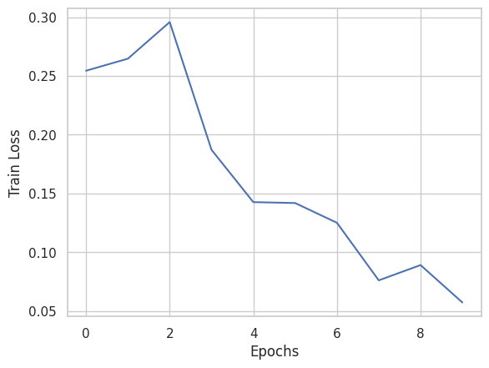
Figure 2.1: Train Loss by Epochs

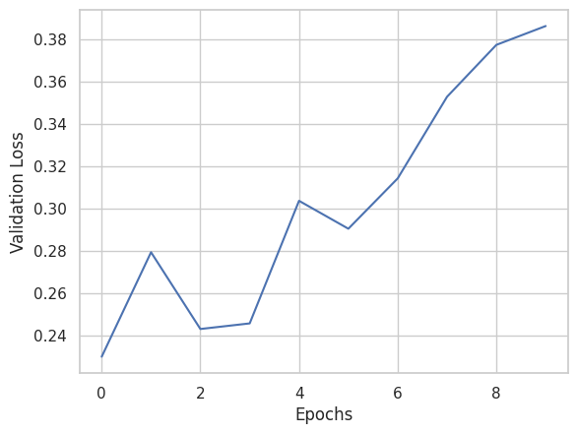
Figure 2.2: Validation Loss by Epochs

As we can see, the train loss has a downward trend while the validation loss has an upward trend. This is an obvious sign of overfitting. We can see that the validation loss is minimum at the second epoch, suggesting that the F1-score might be best at the second epoch. However, changing the number of epochs to 2 only reduced the score. When we looked further into it, the F1-score seemed to be increasing with each epoch. We also noticed that increasing the number of epochs to above 10 did not increase the F1-score. Rather, the F1-score only kept varying in the range 0.38 - 0.40.

On checking the model’s F1-scores on each sentence one-by-one, we tried to see if we can get any clue to how we can improve the model’s performance. However, this turned out to be another deadend among several other efforts.

Evidently, we need to study and experiment more with the RoBERTa model such as its architecture, all the hyperparameters, or perhaps more steps in the preprocessing stage to reduce the imbalance of the tags. The performance of the model can surely be improved to a satisfactory score with enough time and effort, and could then be implemented on a larger scale such as the vice president’s speech, the director’s speech, etc.

2.5.4 BART Summarization Model

BART (Bidirectional and Auto-Regressive Transformer) is a sequence-to-sequence (Seq2Seq) model introduced by Lewis et al. in 2020, with the aim of improving the generation of coherent and well-structured text. BART is built upon the architecture of the Transformer, a popular neural network model known for its success in various natural language processing (NLP) tasks.

BART is pre-trained by
- corrupting text with an arbitrary noising function, and
- learning a model to reconstruct the original text.

BART combines both auto-regressive and denoising objectives, allowing it to handle tasks such as text generation, text completion, and text summarization effectively.

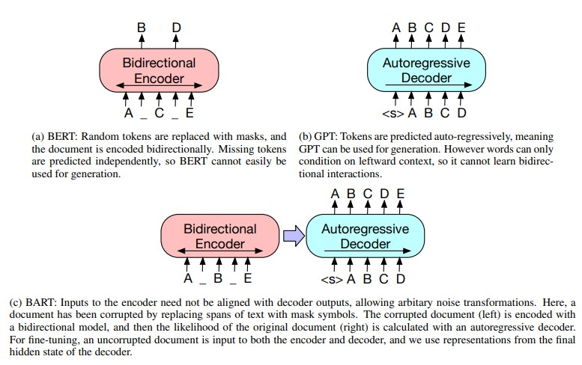
Figure 2.3: Schematic comparison of BART with BERT and GPT

Image taken from original paper BART: Denoising Sequence-to-Sequence Pre-training for Natural Language Generation, Translation, and Comprehension

One of the key strengths of the BART model lies in its ability to handle both masked language modeling, akin to BERT, and autoregressive generation, similar to GPT models, within a single framework. This versatility enables BART to perform exceptionally well in various NLP tasks, including abstractive text summarization, where it has exhibited promising results in producing concise and coherent summaries from longer texts. By leveraging a pre-trained model that has been fine-tuned on a large corpus of data, BART can effectively capture the nuances and context of the input text, leading to high-quality abstractive summaries that preserve the key information and salient points of the source content.

It matches the performance of RoBERTa with comparable training resources on GLUE and SQuAD, achieves new state-of-the-art results on a range of abstractive dialogue, question answering, and summarization tasks, with gains of up to 6 ROUGE. BART also provides a 1.1 BLEU increase over a back-translation system for machine translation, with only target language pretraining.

Chapter 3

Model Deployment

We developed a user interface using Streamlit. This interface serves as the front-end for users to interact with the model. Users access the Streamlit interface to provide text documents containing a chairman's speech. Once the user submits the document, the user can either choose to display the keywords of the document or display a summarized version of the document with the click of a button. If the keyword prediction button is clicked, then the content of the uploaded document is fed to our RoBERTa model on the backend which predicts the keywords and displays it on the user interface. If the summarize button is clicked, then the content of the uploaded document is fed to our BART model on the backend which creates a summarized text and displays it on the user interface. Please refer to the snapshot given below for a view of the user interface.

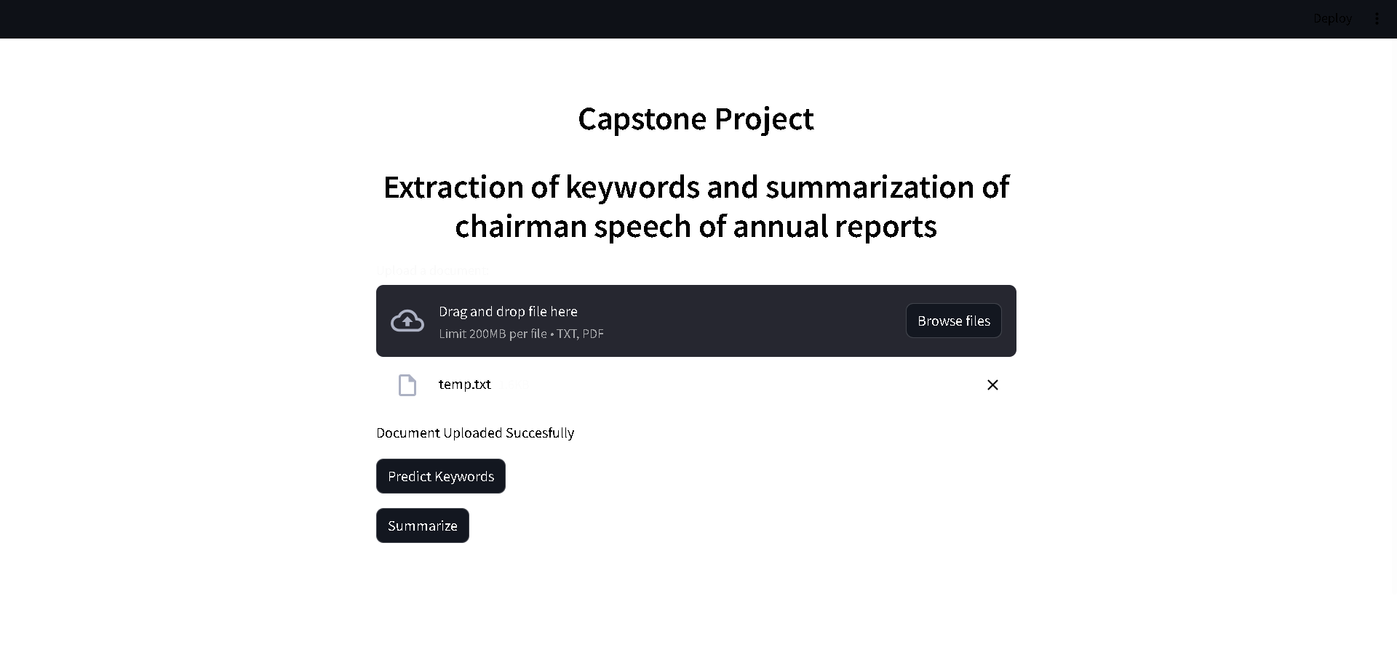
Figure 3.1: Application User Interface

Currently, we have achieved these two functionalities on the model deployment part. We aim to add more functionalities such as displaying a word cloud which would display the keywords where the keywords having the highest importance would be highlighted the most among the remaining keyword corpus. Another functionality we aim to add is to integrate the predicted keywords with the summarization model so that it makes a summarization specifically based on the keywords and the context around them, making the application all the more helpful for having a deeper understanding of a company’s performance and for informed decision making.

Chapter 4

Investment Opportunities
The model can significantly reduce the time and effort required to process and understand extensive annual reports. It can quickly extract critical information, saving valuable time for investors and analysts. The model provides easy access to essential information from annual reports, making it more accessible to a wider audience, including individual investors, small businesses, and students. Summarized information allows investors and analysts to make more informed investment decisions, helping them identify key insights, trends, and potential risks or opportunities. It allows users to stay current with a company's performance and strategies. It can handle large volume of annual reports from multiple companies, making it valuable for institutional investors, fund managers, and financial analysts who need to review reports from various entities. Compared to hiring analysts or purchasing expensive research reports, the model can be a cost-effective solution for obtaining actionable insights. It can serve as an educational tool, helping students and aspiring investors learn how to analyze annual reports and understand the key factors affecting investment decisions.
Summarized reports help identify potential risks, compliance issues, and corporate governance concerns, reducing the likelihood of making uninformed investments. Access to critical information through automated summarization can provide a competitive advantage, especially in fast-moving markets. The model can promote transparency in the investment process by making information more readily available and easier to comprehend. Users can more effectively diversify their investment portfolios by quickly identifying and comparing opportunities across different industries and companies.

Chapter 5

Conclusion and Future Scope
This project has highlighted the importance of the Chairman's speeches as a window into the vision, goals, and communication strategies of companies. The extracted keywords and summarized content offer a comprehensive understanding of the messages conveyed in these annual reports. Such insights are invaluable for investors, stakeholders, and anyone interested in corporate governance and communication practices. This helps with informed decision-making, benchmarking, and a deeper understanding of the priorities and trends across different sectors.

While the model has failed on the validation data with a F1-score of 0.40, we do not believe that it is a complete failure as the model did learn the pattern in the training data and got a F1-score of 0.89. The overfitting issue can definitely be fixed by various methods such as rectifying the errors in the predictions of the validation data and then feeding it to the model as training data while marking keywords in more documents so that we can have a training data of larger than 105 documents. Another method is to study all the hyperparameters of the model, i.e., a total of 87 hyperparameters and experiment with different settings for them.

The problem with the model is merely overfitting which is a very commonly occurring issue in machine learning problems and hence there are various ways to tackle the problem. However, it would require a lot of expertise and knowledge to do so in this case as we are dealing with an NLU (Natural Language Understanding) problem and we are very new to the topic, therefore requiring a lot of time to well research and understand the hyperparameters of the model we have used.

This project can be extended beyond just Chairman speeches to Director’s speech, Vice President’s speech - any textual data that contains a report of a company. Additionally, we are looking to incorporate sentiment analysis, providing deeper insights into Chairman's speeches by assessing their emotional tone and sentiment. We are also aiming to add into the application an ability to identify whether the report or the textual data contains any false, misleading, or inconsistent information regarding a company’s performance.

Chapter 6

Bibliography
- A. Vaswani et al., “Attention Is All You Need”, (2017).
- J. Howard and S. Ruder, “Universal Language Model Fine-Tuning for Text Classification”, (2018).
- A. Radford et al., “Improving Language Understanding by Generative Pre-Training”, (2018).
- J. Devlin et al., “BERT: Pre-Training of Deep Bidirectional Transformers for Language Understanding”, (2018).
- I. Sutskever, O. Vinyals, and Q.V. Le, “Sequence to Sequence Learning with Neural Networks”, (2014).
- V. Sanh et al., “DistilBERT, a Distilled Version of BERT: Smaller, Faster, Cheaper and Lighter”, (2019).
- Y. Liu et al., “RoBERTa: A Robustly Optimized BERT Pretraining Approach”, (2019).
- M. Lewis et al., “BART: Denoising Sequence-to-Sequence Pre-Training for Natural Language Generation, Translation, and Comprehension”, (2019).
- A. Conneau et al., “Unsupervised Cross-Lingual Representation Learning at Scale”, (2019).
- Y. Liu et al., “RoBERTa: A Robustly Optimized BERT Pretraining Approach”, (2019). 4 T. Kudo and J. Richardson, “SentencePiece: A Simple and Language Independent Subword Tokenizer and Detokenizer for Neural Text Processing”, (2018).
- A. Radford et al., “Language Models Are Unsupervised Multitask Learners”, OpenAI (2019).
- M. Lewis et al., “BART: Denoising Sequence-to-Sequence Pre-training for Natural Language Generation, Translation, and Comprehension”, (2019).
- J. Zhang et al., “PEGASUS: Pre-Training with Extracted Gap-Sentences for Abstractive Summarization”, (2019).

- K. Papineni et al., “BLEU: A Method for Automatic Evaluation of Machine Translation,” Proceedings of the 40th Annual Meeting of the Association for Computational Linguistics (July 2002): 311–318, http://dx.doi.org/ 10.3115/1073083.1073135.
- C-Y. Lin, “ROUGE: A Package for Automatic Evaluation of Summaries,” Text Summarization Branches Out (July 2004), https://aclanthology.org/W04-1013.pdf.
- T. Kudo and J. Richardson, “SentencePiece: A Simple and Language Independent Subword Tokenizer and Detokenizer for Neural Text Processing”, (2018).
- https://huggingface.co/facebook/bart-large-cnn
- https://huggingface.co/docs/transformers/model_doc/roberta
- Thilina Rajapakse, “Simple Transformers — Named Entity Recognition with Transformer Models,” https://towardsdatascience.com/simple-transformers-named-entity-recognition-with-transformer-models-c04b9242a2a0

